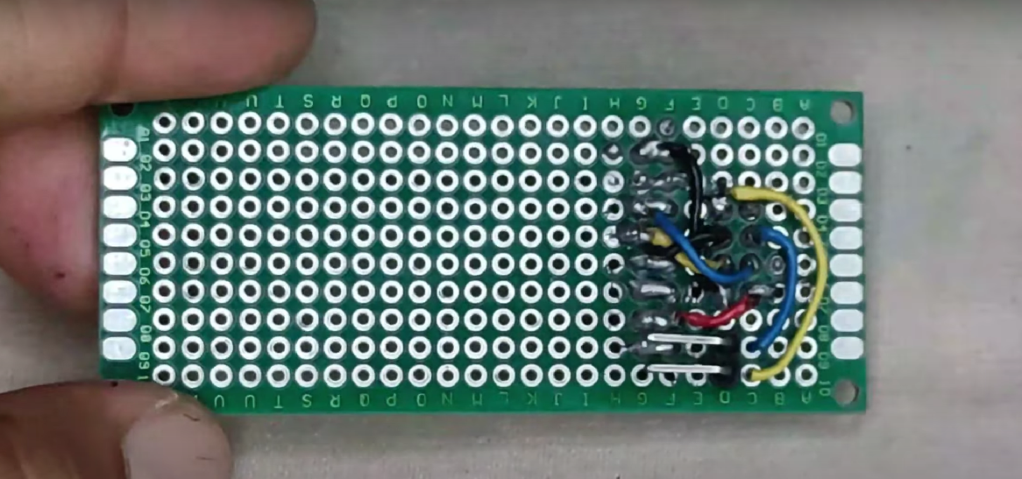

Link YouTube: <https://www.youtube.com/watch?v=XExDZPDiNyQ>

